Group Number: 3

Group Member: Mingjun Yang, Xuanqi Li, Qing Hu, Yutong Yan

**Database Design Document**

**Business Problems**

Our team plans to design a database for **FOOD DELIVERY** platform, which is used for three kinds of users – customers, restaurant owners, and food delivery carries. Therefore, the database should implement the requirements, including storage, search, track and report varied data.

**All Entities**

Users

Restaurant_Owner

Customer

Food_deliver

Restaurant

Cuisine

Restaurant_Cuisine

Dish

Comment

Order

Order_Dish

Payment

Address

City

State

**Relationships:**

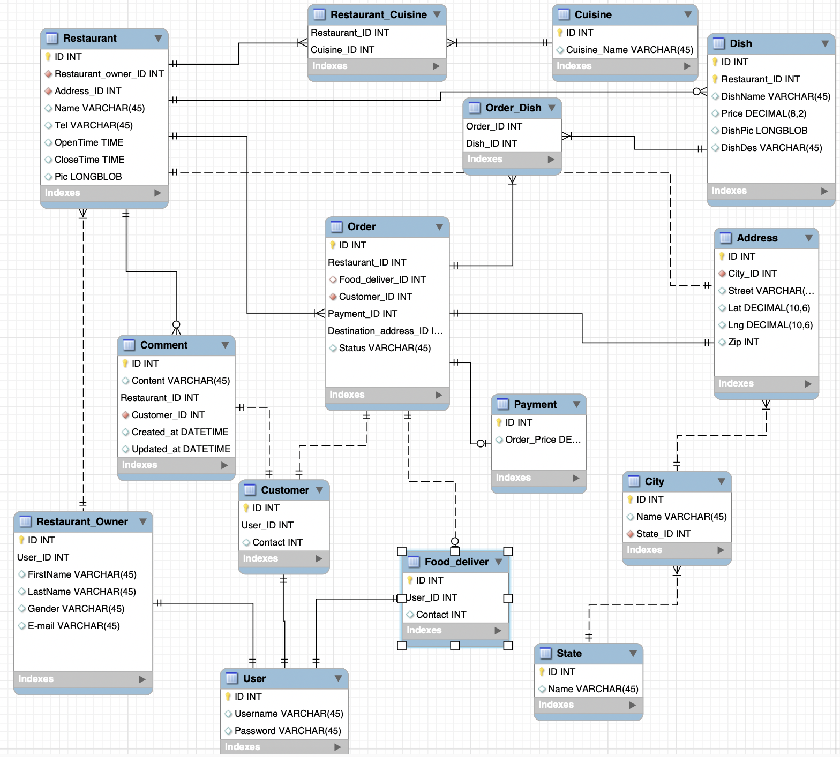

**Key Design Decisions:**

**Our design decisions will address the following questions**

* What entities and why these entities?
* What the PKs and FKs of each entity?
* What attributes contain?
* How the entity is related to others? And why?
* 1:1 or 1:n ?

**Decision Explanation:**

1. **Restaurant & Restaurant-Cuisine & Cuisine**

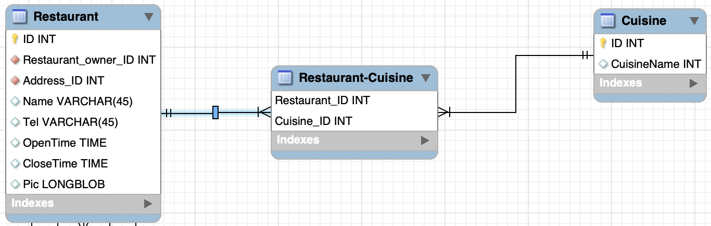

**Explanation:** One restaurant can be classified into several cuisines, such as Hot-pot is a kind of Asian Food, as well as Chinese Food. Additional, one cuisine contains several restaurants. In order to search a Restaurant depending on Cuisine, we design a table named Restaurant-Cuisine to present this many-to-many relationship. Moreover, Restaurant_ID and Cuisine_ID are both primary keys, therefore the three entities are in an identifying relationship.

1. **Restaurant & Dish**

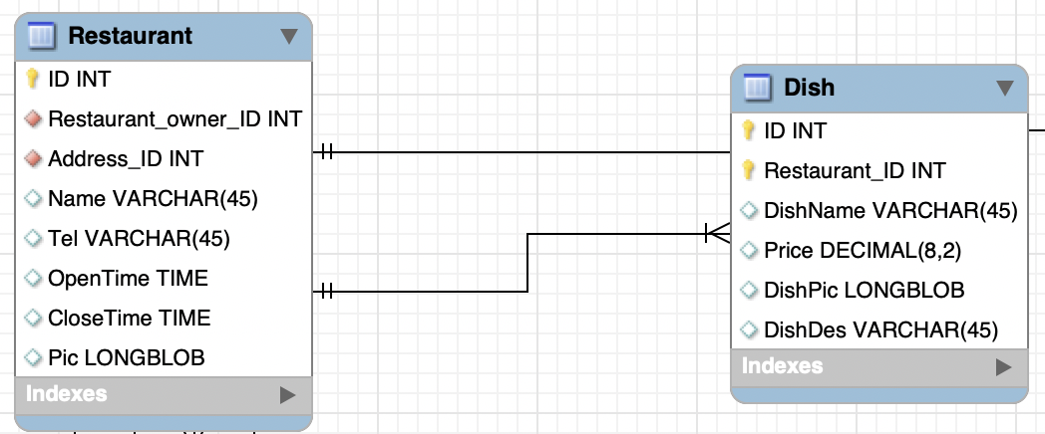

**Explanation:** This is a one-to-many relationship between Restaurant and Dish, because one restaurant could serve varied dishes. For dish entity, in order to distinguish dishes between restaurants, we need two primary keys. They are dish ID and Restaurant_ID.

1. **Restaurant & Restaurant_owner**

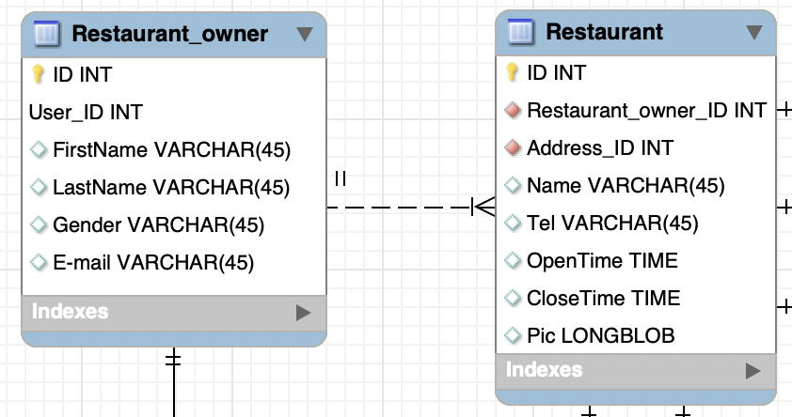

**Explanation:** This is a many-to-one relationship between Restaurant and Restaurant_owner, because one restaurant has one owner, however one owner may have several restaurants. In addition, there is no common primary key, so these two entities are non-identifying. In Restaurant entity, Restaurant_owner_ID is seemed as a foreign key.

4. **Order&Restaurant&Address**

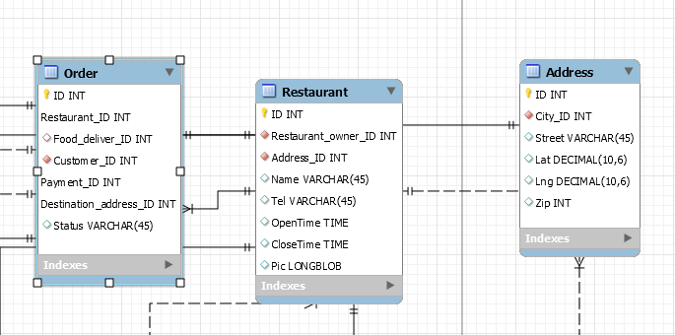

**Explanation:** One restaurant can have several orders. Every order will have only one address of a restaurant. When Restaurant_ID, Payment_ID, DestinationAddress_ID are primary keys.Restaurant&Order, Order&Address are identifying relationship. Restaurant&Address are non identifying relationships. Order: Restaurant_ID is FP.

**5. Order&Order_Dish&Dish**

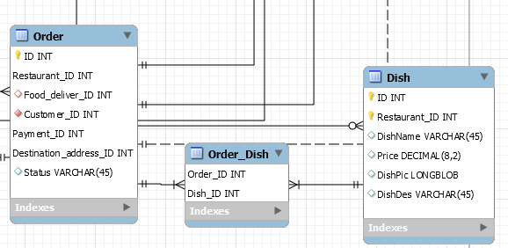

**Explanation:** This is a many-many relationship between Order and Dish. We define Dish as a specific type of food like noodles, burgers, etc. So one order can have many dishes and one dish can be ordered in many orders. Restaurant_ID, Payment_ID, DestinationAddress_ID are primary keys. There are identifying.

**6. Address&City$State**

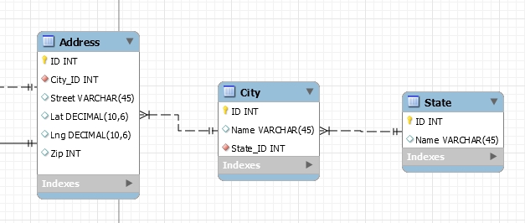

**Explanation:** In the US, there are many cities in one state and thousands of address in a city. So there is a many-one relationship between city and state and there is a many-one relationship between address and city. City: State_Id is FP. Address: City_ID is FP. no PK.

**7. Order&Payment**

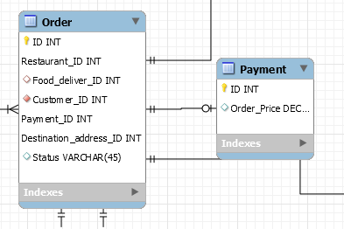

**Explanation:** One order has only one payment so there is a one-one relationship. Payment: no FP.

**8. Order&Food_Deliever&User**

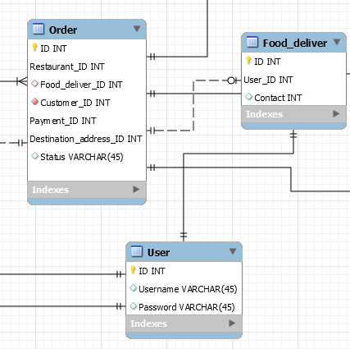

**Explanation:** One man delivers one order, but when an order starts, there will be no food deliver so it is optional for Food_Deliver, and it is non-identifying.

Food_Deliver: User_ID is FP. When deliveryman is confirmed, there is a one-one and identifying relationship between User and Food_Deliver.

**9. Comment&Cusotomer&User**

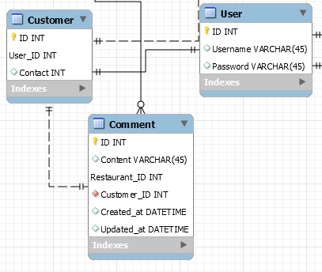

**Explanation:** A customer must have a User and comment so there is a one-one relationship between comment and customer, customer and user.

Customer: User_ID is FK.

Comment: Restaurant_ID is FK. The relationship between comment and customer is non identifying and the relationship between customer and user is identifying.